***Software Engineering Process Layer***

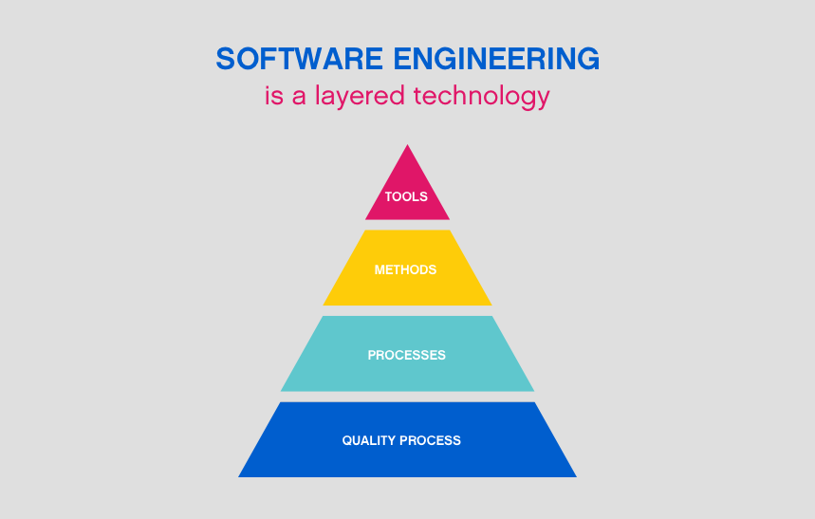

***ANDROID BASED LIVE NOTIFICATION TIME TABLE TRACKER***

***PROBLEM STATEMENT:***

Due to busy schedule, we sometimes forget our time table and have to search around for it to know which lecture we have and what our faculty is going to cover.

Solution Domain:

We attempt to solve this problem using mobile notifications . Notification are to be sent at given interval according to the timetable, so that students get to know the lecture they are going to attend and the timings of the lecture so that they can come on time and prepare themselves for the following lecture. The same notification will be sent to the faculty so that they can react accordingly, and can manage their schedule effectively; so that they can focus on other important stuffs.

* Students can come on time.
* Faculty won't have to wait.
* It will make the best of time utilization.
* If time table gets updated, the students and faculty will get to know
* If a faculty is absent the students will get to know, and use the lecture accordingly.

***TOOLS REQUIRED:***

1. Android Studio for Android app development.
2. Online database for storing the time table in real time.
3. Online user authentication and admin system.

***WORKFLOW DIAGRAM:***

Student/Faculty signs up on our app and select their class.

Students /Faculty receive notification for their classes and never miss any class!

Agile Model

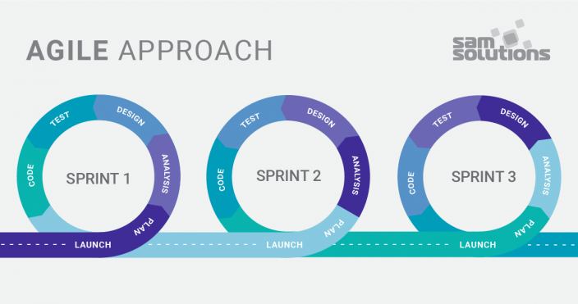

Agile model is a combination of iterative and incremental process models. It focuses on adaptability and customer satisfaction by rapid delivery of working software product. Agile Methods break the product into small incremental version. These versions are provided in iterations as an intermediate. Each iteration typically lasts from about one to three weeks. Each iteration involves a no of teams working simultaneously on various areas like −

* Planning
* Requirements Analysis
* Design
* Coding
* Unit Testing and
* Acceptance Testing

At the end of the iteration , a working product is displayed to the customer and important stakeholders. In this way we get an end of all iteration a final version is produced according to customer requirement for a release. Agile model believes that every project needs to be handled differently and the existing methods need to be tailored to best suit the project requirements. It is considered to be quiet flexible and adaptable.

The most popular Agile methods include Rational Unified Process (1994), Scrum (1995), Crystal Clear, Extreme Programming (1996), Adaptive Software Development, Feature Driven Development, and Dynamic Systems Development Method (DSDM) (1995). These are now collectively referred to as **Agile Methodologies**, after the Agile Manifesto was published in 2001.

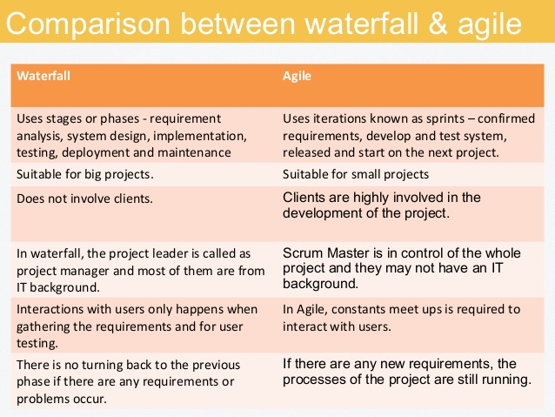

Due to these reasons we can say that agile model is better than waterfall model.

REQUIRMENT GATHERING AND ANALYSIS-

Software requirements can be described by two types:

* Functional requirements
* Nonfunctional requirements

Functional requirements allow describing the functionality of the application. For example, let’s see the list of functional requirements for our application:

* The application sends notifications.
* The app must support internet transfer.

Nonfunctional requirements are needed to describe design aspects and functional requirements. The nonfunctional requirements:

* The app must work in browsers.
* Mobile layouts must be supported.
* The app must have a dark mode.
* The application contains a timer.

Now let’s see the features that are necessary for the high-quality requirements of the software product. They must be:

1. Correct
2. Unambiguous
3. Complete
4. Consistent
5. Verifiable
6. Modifiable
7. Traceable

